EXERCISE 5 - Fibonacci with OpenMP tasks
Files : fib_serial.c (given serial code)
fib_parallel.c (task parallel version)
Compile / run
gcc -O2 -fopenmp fib_serial.c -o fib_serial && ./fib_serial 40
gcc -O2 -fopenmp fib_parallel.c -o fib_parallel && OMP_NUM_THREADS=4 ./fib_parallel 40

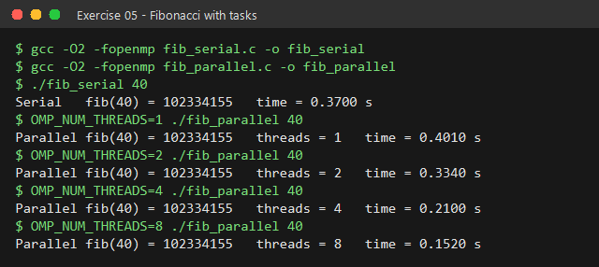
Parallelisation
---------------
#pragma omp parallel // create the thread team
#pragma omp single // ONE thread starts the recursion
result = fib(n);

int fib(int n) {
...
#pragma omp task shared(i) i = fib(n-1); // child task 1
#pragma omp task shared(j) j = fib(n-2); // child task 2
#pragma omp taskwait // wait for both
return i + j;
}

* Each recursive call becomes an independent TASK that any idle thread in
the team can pick up.
* shared(i,j) lets the child tasks write back to the parent's variables;
taskwait makes the parent wait until both children are done.
* Below a cut-off (n < 20) the code falls back to plain recursion,
otherwise millions of tiny tasks would cost more than they save.

Results
-------
version threads time (s) speed-up
------- ------- -------- --------
serial - 0.370 1.0
tasks 1 0.401 0.9
tasks 2 0.334 1.1
tasks 4 0.210 1.8
tasks 8 0.152 2.4

Result is identical (fib(40) = 102334155) in every run; time drops as
threads are added.

